How do I access Emerald Submit?

The Emerald Submit website is accessible via the URL https://submit.emerald.com.

IMPORTANT NOTE: The system takes your submission and the email address you used for the submission on ScholarOne in order to populate your author dashboard. Therefore, your Emerald Submit account should ONLY be created using the email address with which you submitted your paper in ScholarOne. If your email addresses do not match you will be unable to use Emerald Submit.

Registering and logging in is straightforward. Simply visit the login page and you will have the choice of registering a new account, or logging in with your existing one:

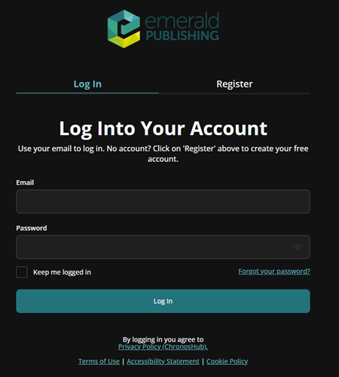
From this screen you will also be able to reset your password if you have forgotten it.

